2024 Committee Candidate Statements

NOTES
Candidates appear in alphabetical order based on their first name pursuant to section 49(4) of the QUT Law Society Inc. Constitution.

The number which appears next to a candidate’s name is the order of their preference for the role. Candidates were allowed to nominate up to three (3) preferences.

The positions of Design Officer and Photographer are not eligible for election as these roles are made by appointment only. These roles will be advertised in early 2024.

Nomination for positions from the floor of the AGM
Positions which have received one (1) nomination or less will reopen for nomination from the floor of the AGM. These positions include:
- Treasurer
- Director of Diversity, Culture and Wellbeing
- Director of External Competitions
- Director of Internal Competitions
- Director of Moot Club
- Director of Sponsorship
- Director of Sport and Health
- George Street Journal Officer
- Abilities Officer
- DCW Officer
- Gender and Sexuality Officer
- Mentor Officer
- Merchandising Officer
- External Competitions Officer
- First Nations Officer
- Internal Competitions Officer
- IT Officer
- Publications Officer
- Moot Club Officer

Candidates who wish to nominate themselves for a position on the floor of the AGM will need to speak to the returning officers to formally nominate. If the candidate has already provided three (3) preferences, they must withdraw one of their nominations before nominating for a new position.

Election Procedure
All candidates are invited to attend the QUT Law Society Inc. AGM and Election to present a speech and/or respond to questions from the membership. The AGM is scheduled to be held on Sunday 29 October beginning at 10am in room C405 of C Block, at QUT Gardens Point Campus.

Any member who is unable to attend in person must email the QUT Law Society Inc. Secretary Harry Bass before Friday 27 October at 10am to request online attendance.

Candidates will be required to present an election speech for each position nominated at the election. The permitted speech times are as follows:

- Management Committee role: 2-minute speech followed by 4-minute question time.
- Director role: 1-minute speech followed by 2-minute question time.

Officer role: group question time of 1 minute per nominee of that position.

Voting

To vote, you must attend the election either electronically or in person, and you must be an Associate Member of the QUT Law Society Inc. An Associate Member is a person who has purchased a 2023 QUT Law Society membership (the ‘Playing Card’) and is currently enrolled in a QUT law degree.

To attend electronically, you must email the Secretary (secretary@qutlawsociety.com) prior to the event outlining your reasons for attending electronically. Your virtual attendance will need to be approved.

Voting will occur by secret ballot following the AGM. A voting key will be sent to each member who attends the AGM. Results of the election are anticipated to be released by Wednesday 1 November.

Table of Contents
NOTES 2
I. MANAGEMENT COMMITTEE 6
President 6
Vice President 11
Secretary 13
Treasurer 15
II. EXECUTIVE COMMITTEE 16
Director of Creativity 16
Director of Diversity, Culture and Wellbeing 19
Director of Education 20
Director of Events 22
Director of External Competitions 24
Director of Internal Competitions 25
Director of Media and Communications 26
Director of Moot Club 28
Director of Sponsorship 29
Director of Sport and Health 30
Director of George Street Journal 31
III. OFFICER ROLES 33
Creativity Portfolio 33
Law Revue Officer (2 Roles) 33
Diversity, Culture and Wellbeing Portfolio 37
Abilities Officer 37
DCW Officer 37
First Year Officer 38
Gender and Sexuality Officer 41
Education Portfolio 42
Education Officer (2 Roles) 42
Mentor Officer 46
Events Portfolio 47
Events Officer (2 Roles) 47
Merchandising Officer 50
External Competitions Portfolio 51
External Competitions Officer 51
First Nations Officer 51
Finance Officer 52
Internal Competitions 54
Internal Competitions Officer (4 Roles) 54
IT Officer 56
Media and Communications Portfolio 57
Publications Officer (2 Roles) 57
Social Media Officer 58
Moot Club Portfolio 59
Moot Club Officer 59
Sponsorship Portfolio 60
Sponsorship Officer 60
Sport and Health Portfolio 63
Health Officer 63
Sport Officer 65

MANAGEMENT COMMITTEE

President

- Ethan Nguyen (1)
President Candidate Statement
My name is Ethan Quoc Nguyen, and I am a 3rd-year law student here at QUT. My journey up to this point, like that of many, has been one of growth, introspection, and transformation. As I pen down this nomination statement, I feel compelled to share a candid reflection.
In the early days of my academic journey, I stayed on the periphery of the vibrant QUT Law Society. I watched from a distance, abstaining from active involvement. This choice, while seemingly safe at the time, bore consequences that I felt deeply. Not being an active member meant I missed out on connections, experiences, and opportunities to serve and connect with my peers. It left a void - one that served as a stark reminder of the costs of hesitation and the value of participation.
But every story has its turning points. Recognising the weight of missed opportunities, I've committed myself to being vulnerable, to pushing past my reservations, and to seizing every chance that presents itself. And today, I stand before you with a clear purpose: to serve the brilliant minds of QUT with dedication, enthusiasm, and a drive that stems from my very own lessons.
As I put forth my nomination, it isn't merely for a position. It's a commitment to change, to involvement, and to creating a legacy where every student feels heard, valued, and empowered. I've learned the importance of community and participation first-hand, and it's that invaluable lesson I wish to bring to the forefront of our society.
I am here, not just for myself but for every student who's ever felt hesitant or unsure. I aim to foster a space where no opportunity is left untapped and where every member feels an integral part of our thriving community.
In me, you'll find a representative eager to listen, ready to act, and devoted to ensuring that our QUT Law Society remains a beacon of inclusion, growth, and excellence. Together, let’s create a society that celebrates every individual, every idea, and every possibility.

- Harrison Megom (2)
President Candidate Statement

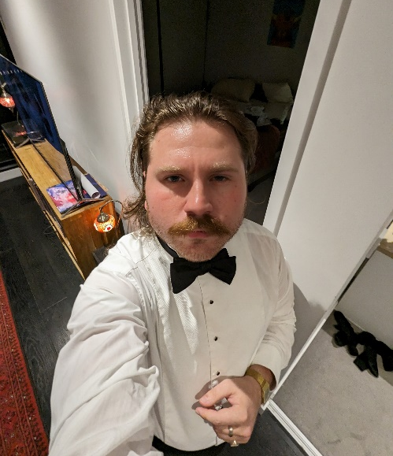
In my time as a student, I have spent a lot of time in an d around the QUTLS. As such, I owe a lot of my university experience to it, and as such wish to be president to help guide the QUTLS help a new generation of students have a great university experience and learn about all the wonderful opportunities that the law society provides.
I served as the Director of Creativity this past year, and was able to usher in new cast members to the Law Revue, resulting in one of the best shows we have ever put on, and hopefully I can do that for the entire society.

- Lachlan Berlin (2)
President Candidate Statement

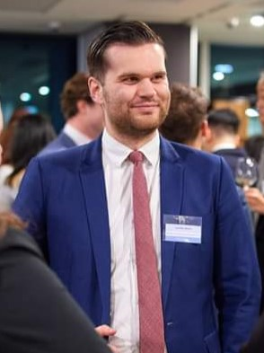
Ever since I made the monumental decision to quit my full-time job as a journalist in regional Queensland, move to Brisbane and study law, QUTLS has provided me so many opportunities for career networking, competitions, personal development and events. Having also served as Director of Moot Club in 2023, I have experienced the Society from both a participant and committee perspective. I am in my final year of my degree and would be honoured to have the privilege of giving back to the QUTLS as President.
Here's what I can bring to QUTLS:
• Experience. I have learnt the ins-and-outs of QUTLS, how to organise events, and the challenges facing the committee.
• Dedication. Management Committee is a gruellingly rigorous commitment, but I welcome the challenge. I have managed a full-time workload with a job and QUTLS commitments well and am prepared to make myself readily available to assist the committee when needed.
• New ideas. I rebuilt Moot Club so it could run throughout the whole year and so future committees have a strong foundation to develop the portfolio.
• Networks. I attended ALSA as a competitor and met many people from Australian student societies. I also helped finalise the transition of High School Moot to Faculty, while maintaining opportunities for our students to participate.
Here’s what I’d like to promote in 2024:
• More Qpay Playing Card benefits, especially to reward continued attendance at QUTLS activities.
• Stronger collaboration between portfolios. The cross-collaboration Moot Club helped to promote between the 3 mooting/comps portfolios is a testament to how we can all benefit when we work together.
• Stronger networks and more opportunities with external stakeholders and other law societies.
• More structure and flexibility to promote committee members’ mental health and to ensure all portfolios remain active year-round.

- Laila Bowden (1)
President Candidate Statement

Hello! My name is Laila and I am running for President in 2024.
My journey began with QUTLS in 2022 when I applied to be the Social Media Officer. I originally applied because I wanted to feel more connected to my university experience. Starting my law degree in 2021 in a post-pandemic world, I felt like I was just submitting assignments into the abyss. Joining the QUTLS has truly enriched my university experience as I now know way more about my degree and have made some genuine connections with some amazing people

For 2023, I ran for Director of Education. This was certainly a step up from my Officer role, but has been such an enjoyable challenge. I feel like the Education Portfolio events this year have been very successful, helpful, high quality events. This evidences my commitment to my role and also my ability to effectively manage people. What really motivates me in my current role is when I receive sweet feedback from members about how much they enjoyed an event. This reminds me why I love volunteering with this society.

As President, I would strike a balanced approach between professionalism, empathy, and autonomy. In practice, this looks like setting firm professional standards, but also giving Portfolios creative autonomy and being a support person when need be. Whilst I am proud of everything we have done this year, I also think we need to adopt a slightly different direction moving forwards. I think university life looks different to how it did pre-COVID and we need to work on how to digitally adapt to ensure we aren't left behind. Change is a daunting, but necessary evil to ensure longevity as an organisation.

Thank you for reading my statement, I look forward to touching on my application more at the AGM!!

- Tobias Quy Verlander (1)
President Candidate Statement

Your time is precious allow for me not to spare any more than is necessary. My nomination statement is simple, I believe it will be in the law societies and to my fellow peers' best interests to have me on board in the positions of President, Director of Events or George Street Journal Director. I've had a productive history of people management whether that take place in the home life, school or sport. My burning passion for understanding people has led me to delve into much personal research of psychology, particularly that of what makes a great leader. Naturally I take fondly to public speaking and deeply yearn to inspire others through my words. Similarly in being responsible for events my ability to listen to you, the law society member, is one of my key skills. Needless to say this resides in conjunction with my creative talent for fun ideas like a James Bond themed law ball or a dog meet-up in law. To tie this all together I bring you my talent, passion and life long skill of humour to the George Street Journal, you really won't regret it.To convince you with an extensive list of my accolades is however, futile. You, the reader, understand well that actions speak louder than words. So allow for my actions to speak, take a chance on me.

Vice President

- Lachlan Berlin (3)
Vice President Candidate Statement
I see the role of Vice-President as not only assisting the President and other Management Committee members, but also supporting and promoting the interests of directors and officers. Being a director gave me experience in organising events, reaching out to guests, coordinating other committee members and ensuring everything runs smoothly. Directors and officers are the bread and butter of QUTLS and I want to help out wherever I can to put their ideas into action.
Here's what I can bring to the Vice-President role:
• Experience. I have learnt the ins-and-outs of QUTLS, how to organise events, and the challenges facing the committee.
• Dedication and openness. Management Committee is a gruellingly rigorous commitment, but I welcome the challenge. I have managed a full-time workload with a job and QUTLS commitments well and am prepared to make myself readily available to assist the committee when needed.
• The not-so-nice stuff. I am willing to jump in if there are any difficult tasks a committee member needs help with, like resolving a conflict, dealing with difficult stakeholders, or managing others who aren’t pulling their weight.

Here’s what I’d like to promote in the role:
• Empowering directors and officers. I don’t want portfolios to feel like they can’t do something because of imposter syndrome or the ways of old. I want to help ensure QUTLS is suited for 2024.
• Stronger collaboration between portfolios. The cross-collaboration Moot Club helped to promote between the 3 mooting/comps portfolios is a testament to how we can all benefit when we work together.
• More structure and flexibility to promote committee members’ mental health and to ensure all portfolios remain active year-round. We can provide more opportunities and responsibilities to officers to reduce the stress on directors.

- Marli Simpson (1)
Vice President Candidate Statement

Hello! My name is Marli Simpson and I’d love the be the QUTLS Vice President for 2024. For a bit of background about me, I moved to Brisbane from Adelaide in 2021 and the QUTLS provided me with my first friendships and industry connections upon moving. I truly value what the QUTLS can provide to students and hope that I can work to continuously improve opportunities available for 2024.

In 2023, I have been the Director of External Competitions and within this portfolio provided students with the opportunity to compete at a range of national competitions such as the ALSA Competitions and the Baker McKenzie Women’s Moot in Sydney. With the Queensland Intervarsity Law Competitions (‘QILC’) on the brink of not proceeding, I decided to organise it in it’s entirety. This competition now has 6 competing universities and a range of Queensland Supreme Court Justices and industry professionals judging and assisting teams. My 2023 role within the society goes to demonstrate my commitment to QUT students and my ability to showcase strong organisational skills to see my visions come to light. If I was elected as Vice President for 2024, I would be dedicated to achieving the ideas of the executive committee, as well as my own, including enhancing social media engagement, expanding our industry connections and making our events and competitions more accessible.

Secretary

- Lachlan Berlin (1)
Secretary Candidate Statement

Somebody once told me that I always have the Constitution open. (The QUTLS one, but the other one’s a good read too!) I see the Secretary’s role as ensuring compliance with laws and the Society’s rules, while ensuring things like insurance are up-to-date. I am willing to help out any portfolio when they need something organised.

Here's what I can bring to the Secretary role:
- Knowledge. Out of either boredom, curiosity or excitement, I have read the Constitution, By-Laws and Associations Incorporations Act 1981 (Qld).
- Experience. When I was living alone, I organised my own insurance, rental leases and bills. I feel equipped to ensure QUTLS’ agreements are up to date. Having given individual responses to many questions for help as Director of Moot Club, I am keen to manage the Society’s main publicly available email address.
- When managing my full-time workload, a job and QUTLS well in the past, I always tried to stay on top of things and complete them as promptly and diligently as possible. It is so important for a Secretary to stay on top of everything and complete all tasks in a timely manner.
Here’s what I’d like to promote in the role:
- More structure and flexibility to promote committee members’ mental health and to ensure all portfolios remain active year-round. We can provide more opportunities and responsibilities to officers to reduce the stress on directors.
- Reform and flexibility. It is important to ensure compliance, but we can maintain flexibility by changing the by-laws and constitution to be suitable for current conditions.
- Keeping the website and all internal documents up to date. The current by-laws etc. should be available ASAP after change.

- Marli Simpson (2)
Secretary Candidate Statement

Hello! My name is Marli Simpson and I’d love the be the QUTLS Vice President for 2024. For a bit of background about me, I moved to Brisbane from Adelaide in 2021 and the QUTLS provided me with my first friendships and industry connections upon moving. I truly value what the QUTLS can provide to students and hope that I can work to continuously improve opportunities available for 2024.

My second preference is to be the Secretary for 2024. Most people know me as organised and super meticulous with deadlines; these are two perfect characteristics for a secretary. As noted in my Vice President statement, in 2023, I organised the QILC (while also having a broken ankle, studying full time and working 4 days a week). This competition involved contacting and organising hundreds of people to ensure the competition ran as smoothly as possible. In helping me achieve this, I made sure to delegate tasks and create achievable deadlines while keeping a record of all my plans. My extracurricular experience as well as my work experience as a Junior Legal Assistant, demonstrates that I would certainly have the ability to undertake the Secretary role. Overall, I believe I can make a valuable contribution to the management of the QUTLS in either the Vice President or Secretary role because I understand the value of this society and the hard work involved in providing for the diverse needs of each portfolio.

Treasurer

- Gabrielle M Bielawski (1)
Treasurer Candidate Statement

My name is Gabrielle. I’m a Graduate Entry law student, going into my penultimate year in 2024.

My undergraduate degree was an extended major in Linguistics with a double minor in Mandarin and Aboriginal & Torres Strait Islander Studies.

I currently work as the Queensland Spirit Specialist for a global spirits company, managing national sales deals, key accounts, group accounts, and international hotel accounts in Far North Queensland. I work across numerous diaries and host events in key cities such as Sydney and Melbourne. Within one year working in my position, I have successfully increased Queensland’s Moving Annual Total purchasing from $3.2 million to almost $4 million in a post-pandemic arena, leveraging and creating assets, renegotiating deals, and amending budgets, as well as increasing value per dollar spent while national data illustrated a decrease in volume.

My commitment to not only the legal sector but with the law student experience runs deep.
As someone pursuing her postgraduate studies in Law, I’ve had a number of years experience understanding and the living out the needs that students require on a foundational level, as well as on a level that ensures quality, enrichment of experience, and memories for years to come. I believe I can achieve this while thoroughly maintaining a healthy and thriving budget for the Law Society.

I would be thrilled to be elected as the QUTLS Treasurer where I can offer my skills and knowledge in finance, as well as leveraging my contacts in the industry to provide a memorable and rich experience for QUT Law Students.

Thanks for your consideration, everyone!

EXECUTIVE COMMITTEE

Director of Creativity
- Charles Platt (3)
Director of Creativity Candidate Statement
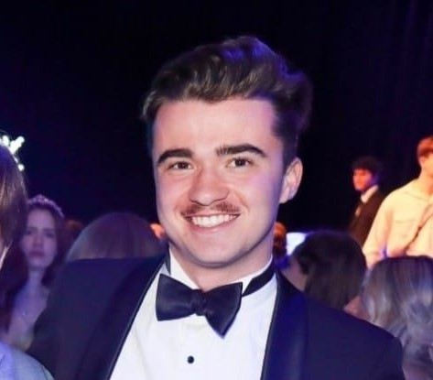
I’m Charlie, and I’m nominating for George Street Journal director. As the current GSJ and former Law Revue Officer, I understand all too well the responsibilities that such a position will entail both within its own portfolio, and across the QUTLS as a whole.

The recent separation of the Journal as an entity distinct from the creativity portfolio brings with it a unique, but exciting set of opportunities and challenges in the coming year, most notably the potential increase in interaction and integration with the rest of the society, while still maintaining its creative, humorous roots.

As director I will seize this opportunity, transforming the GSJ from the strange middle child of the creativity portfolio to a genuine engagement machine, with my inbox open to any director or officer who wishes to promote their event with a more comic bent.

Naturally of course, the GSJ will remain a satire page at its core, and I personally have a body of work in the Journal stretching back to 2021. As always I remind everyone that you are more than welcome to send me article submissions, and I would love to see our body of writers grow next year.

I have also named Law Revue Officer and Creativity director as my 2nd and 3rd choice respectively. While GSJ director is of course my first preference, I would be more than willing to step into these shoes if necessary, having served as Law Revue Officer in 2022.

- Georgia McCosker (1)
Director of Creativity Candidate Statement

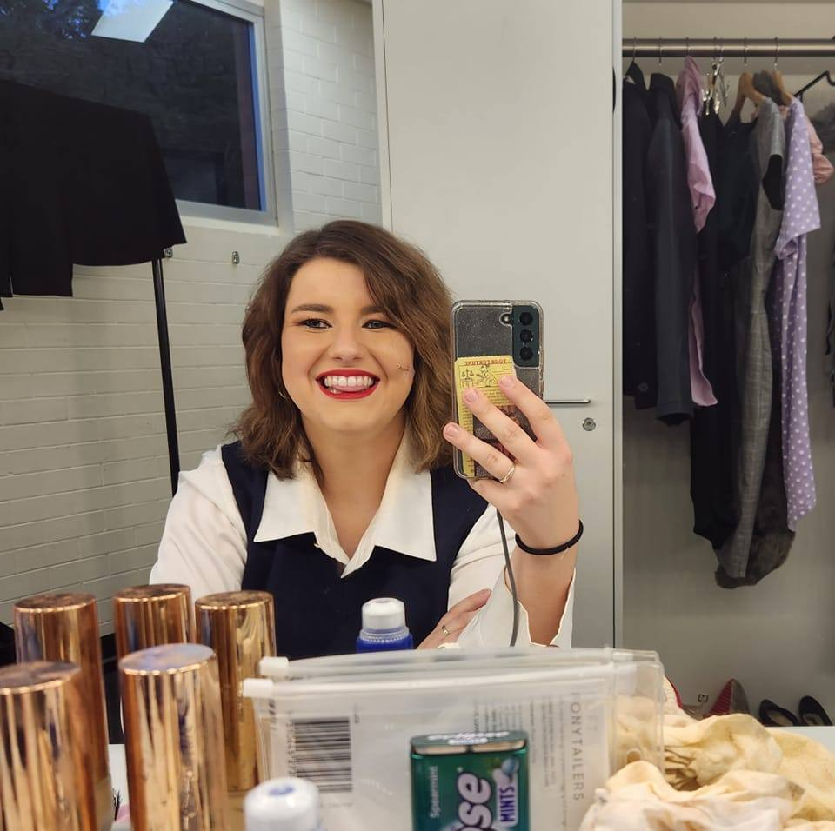
This year I have had the honour of being the Law Revue Convenor. I could not be more grateful for the opportunity to shape the show, or prouder of the performances we gave. Watching the cast band together and knowing that I was a part of making that happen – it was such a rewarding experience.
Since I started participating in Law Revue in 2021, I have had some of my happiest and most creatively satisfying experiences. I have also been blessed with such a wonderful group of friends who I all met through the Revue in some form of another.
But many of our cast members have graduated and moved on now, which means that we need to bring the joy and comradery of Law Revue, to a whole new group of people. I want to ensure that we can make this as positive and uplifting an experience for them, as Law Revue was when I started.
In three years of participation, I have proven my dedication and love for the Law Revue. I have consistently demonstrated my ability to work well within a team and to make others feel safe and supported. I have stepped up to whatever challenge or task is required, and I have taken every opportunity I could to help the show reach its full potential.
To do this, we need our director to be someone organised, approachable, and passionate, to create a safe space and provide the cast with the tools to come together as a group. I think I have demonstrated these skills in my role as convenor this year, and I think these skills will only be improved by the fact that I now have the experience and understanding of what is required to bring the show together behind the scenes.

- Tom Cockburn (1)
Director of Creativity Candidate Statement

Hello friends! Since 2021, I've been involved in the QUTLS Law Revue, a journey I cherish. I joined Revue in 2021, nervous about meeting new people, but the friendly environment quickly made me feel right at home. Joining the Revue is one of my best university decisions, leading to lifelong friendships, law society involvement, and a chance to embrace my creative side.
I was in the QUT Law Revue cast in 2021 and 2022 and had a blast writing, acting, and providing direction for sketches. The best part being the opportunity to become close friends with the cast. In 2023, I got the chance to step into the role of Law Revue Convenor, where I helped lead our talented cast to put on the 2023 Revue, doing things like planning rehearsals, communicating with faculty, fine-tuning scripts, and handling various admin tasks.
This past year, I've been all about understanding where the Revue stands and trying to help things run smoother. I created spreadsheets to keep track of cast numbers and began making templates that can be used going forward, to ensure the Revue's longevity.
Looking forward my goal is to consolidate the Revue and expand the functions of the portfolio, attract a larger audience, and bring greater exposure to the revue through hopefully conducting events early in both semesters.
My AMEB Voice and Communications credit, law clerk experience, and Law Revue Convenor role have honed my communication and problem-solving skills, making me a suitable candidate for another leadership role in the Law Society.
I'm eager to build on our existing foundations, solidifying and expanding them in 2024. Law Revue has been a second family and help me connect with the broader law society. I'm excited about the possibility of taking on a Directorship role within the Creativity portfolio in 2024.

Director of Diversity, Culture and Wellbeing

- Ethan Nguyen (2)
Director of Diversity, Culture and Wellbeing Candidate Statement
My name is Ethan Quoc Nguyen, and I am a 3rd-year law student here at QUT. My journey up to this point, like that of many, has been one of growth, introspection, and transformation. As I pen down this nomination statement, I feel compelled to share a candid reflection.

In the early days of my academic journey, I stayed on the periphery of the vibrant QUT Law Society. I watched from a distance, abstaining from active involvement. This choice, while seemingly safe at the time, bore consequences that I felt deeply. Not being an active member meant I missed out on connections, experiences, and opportunities to serve and connect with my peers. It left a void - one that served as a stark reminder of the costs of hesitation and the value of participation. But every story has its turning points. Recognising the weight of missed opportunities, I've committed myself to being vulnerable, to pushing past my reservations, and to seizing every chance that presents itself. And today, I stand before you with a clear purpose: to serve the brilliant minds of QUT with dedication, enthusiasm, and a drive that stems from my very own lessons.

As I put forth my nomination, it isn't merely for a position. It's a commitment to change, to involvement, and to creating a legacy where every student feels heard, valued, and empowered. I've learned the importance of community and participation first-hand, and it's that invaluable lesson I wish to bring to the forefront of our society.

I am here, not just for myself but for every student who's ever felt hesitant or unsure. I aim to foster a space where no opportunity is left untapped and where every member feels an integral part of our thriving community. In me, you'll find a representative eager to listen, ready to act, and devoted to ensuring that our QUT Law Society remains a beacon of inclusion, growth, and excellence. Together, let’s create a society that celebrates every individual, every idea, and every possibility.

Director of Education
- Arash Asgari (1)
Director of Education Candidate Statement

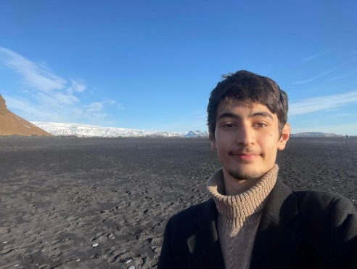
Hello! My name is Arash Asgari and I was previously the External Competitions Officer for QUTLS.
In 2024, I will be a third-year student studying a Bachelor of Law/Business. Currently, I work as a paralegal for Clayton Utz.
My main motivation when joining the QUTLS was to receive support in navigating the confusing and scary world of law as a first-year student. Now in my third-year, I have a solid understanding of my future career pathway, and I want to help other students also ease their anxiety about their future.
If elected as Director of Education, I endeavour to share the vast wealth of knowledge the QUTLS possesses with all students in an accessible and engaging format.
1. Personally, I have attended a majority of QUTLS education events and have a good working knowledge of each event’s unique offering. Additionally, I have conducted thorough research into post-graduate pathways, career prospects, and available professional opportunities; this knowledge positions me well to run an Education-focused portfolio.
2. Professionally, I am a well-organised and ambitious person with astute time management skills, being able to juggle full-time study, part-time work, and other personal obligations. This position me well for the Education portfolio as I can take on the high work volume without drowning in my other responsibilities. Additionally, I have a light subject load next year, have a VERY flexible casual position, and am happy to reduce work hours if needed.
3. QUTLS wise, I was the External Competitions Officer in 2023. In this capacity, I frequently communicated with external stakeholders and drafted several promotional messages for student, firm, faculty, and cross-university distribution. These experiences taught me how to tailor my communication style to accommodate different audiences, which will be highly beneficial for an Educator role.
If elected, I promise my full commitment to the role.

- Ivy Smith (2)
Director of Education Candidate Statement

My name is Ivy Smith, and I am currently completing a double degree in Fine Arts (Film)/Laws at QUT, with a Law, Technology and Innovation minor. I am currently in the second year of my degree and am particularly interested in Australian arts and communication regulation. I see myself one day working for a regulatory body such as ACMA or working in-house as a media lawyer for a production company.
I’m a lover and a taker of all opportunities, and this has led to some very interesting jobs and some very niche interests. Last year I ended up interning for an NFP in India redesigning their digital primary education model – I knew nothing about teaching! I worked recording textbooks for a while, I’ve been an adjudicator for the GC Debating Association for a few years, and I work for Brisbane International Film Festival every October.
Needless to say, I’d had it in the back of my mind in August that I wanted to get involved in QUTLS when I saw a job posting on Facebook (you should follow it). Bingo!
It's definitely been a sprint toward the finish line since then. If elected for 2024, I'm eager to have time to brainstorm with my team ways in which we can take the portfolio in new directions next year. No matter what capacity I’ll be involved in in 2024, I’m keen to do it with this group of people.

Director of Events
- Ethan Lee Hang (1)
Director of Events Candidate Statement

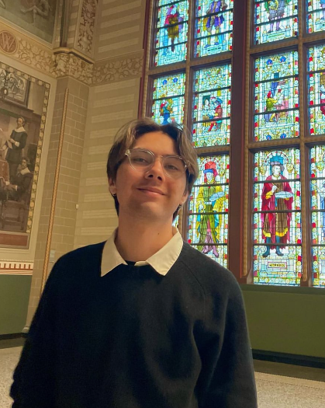
Hello! My name’s Ethan and I’m running for Director of Events for 2024. I have an energetic, enthusiastic and engaging personality and will ensure that you will have the time of your life at all QUTLS related events! I run best when I’m under pressure, and when I’m delivering for an audience. I make little detail in every event has a purpose, a vibe, and is perfect.
As for the main event, we host the most iconic function each year, and I want to ensure that Law Ball 2024 goes down in the history books as the best of the best. A vote for me is a guaranteed good time*! (*I waive all liability for any disappointing actions that occur after any events).

- Harrison Megom (1)
Director of Events Candidate Statement

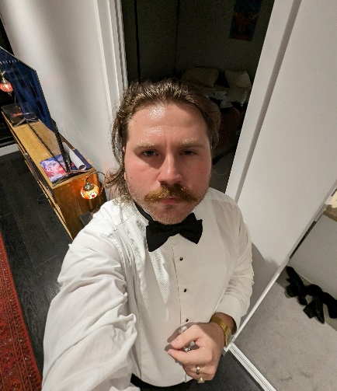
I would like to be in the events because I am passionate about the events that the QUTLS hosts. From Pub Crawl through to Law Dinner, I have enjoyed attending each and every one of them over the years, however I think that more can be done with events and there can be more room for law students to meet and enjoy themselves and get to know one another.
This past year I have enjoyed the responsibility of being the Director of Creativity, and with my team organized multiple events to much success. I believe I have the passion and skill to really guide this portfolio.

- Tobias Quy Verlander (2)
Director of Events Candidate Statement

Your time is precious allow for me not to spare any more than is necessary. My nomination statement is simple, I believe it will be in the law societies and to my fellow peers' best interests to have me on board in the positions of President, Director of Events or George Street Journal Director. I've had a productive history of people management whether that take place in the home life, school or sport. My burning passion for understanding people has led me to delve into much personal research of psychology, particularly that of what makes a great leader.
Naturally I take fondly to public speaking and deeply yearn to inspire others through my words. Similarly in being responsible for events my ability to listen to you, the law society member, is one of my key skills. Needless to say this resides in conjunction with my creative talent for fun ideas like a James Bond themed law ball or a dog meet-up in law. To tie this all together I bring you my talent, passion and life long skill of humour to the George Street Journal, you really won't regret it.To convince you with an extensive list of my accolades is however, futile. You, the reader, understand well that actions speak louder than words. So allow for my actions to speak, take a chance on me.

Director of External Competitions

- Edward Walsh (3)
Director of External Competitions Candidate Statement

My name is Edward Walsh. I am in my second semester of my second year of studying a Bachelor or Laws. For the last year, i have been the Moot Club officer. In this role i helped establish the Moot Club after covid and other such issues in the previous years. In this experience i have interacted with the wider moot portfolio's and have some ideas on how i could improve them moving forward. For any of these roles i would hope to actively engage more with the people in the other two moot director roles, as well as other portfolios to try and encourage mooting to have a more active role in culture of being a QUT Law student.
As such i believe i would be best fit for the role of Moot Club director. In this role i would work on further advancing the social and casual practice aspect of Moot Club. This would hopefully include additional forms of communication for students to stay informed.
Alternatively, i believe i would also be good Internal Moot Director. I have a good understanding of how internal competitions operate through participating and assisting in many. In this role i would keep it running smoothly while aiming to work with the other portfolios to get some more hype around these competitions and more specifically the finals.
Finally, I believe I would make a good External Competition Director. In this role i would aim to create and continue strong relations with other universities, while also using the resources of the Law Society to create more university pride and hype for our external competitors.
Thank you for reading and i hope you consider me for these roles in 2023.

Director of Internal Competitions

- Edward Walsh (2)
Director of Internal Competitions

My name is Edward Walsh. I am in my second semester of my second year of studying a Bachelor or Laws. For the last year, i have been the Moot Club officer. In this role i helped establish the Moot Club after covid and other such issues in the previous years. In this experience i have interacted with the wider moot portfolio's and have some ideas on how i could improve them moving forward. For any of these roles i would hope to actively engage more with the people in the other two moot director roles, as well as other portfolios to try and encourage mooting to have a more active role in culture of being a QUT Law student.
As such i believe i would be best fit for the role of Moot Club director. In this role i would work on further advancing the social and casual practice aspect of Moot Club. This would hopefully include additional forms of communication for students to stay informed.
Alternatively, i believe i would also be good Internal Moot Director. I have a good understanding of how internal competitions operate through participating and assisting in many. In this role i would keep it running smoothly while aiming to work with the other portfolios to get some more hype around these competitions and more specifically the finals.
Finally, I believe I would make a good External Competition Director. In this role i would aim to create and continue strong relations with other universities, while also using the resources of the Law Society to create more university pride and hype for our external competitors.
Thank you for reading and i hope you consider me for these roles in 2023.

Director of Media and Communications
- Ethan Nguyen (3)
Director of Media and Communications Candidate Statement

My name is Ethan Quoc Nguyen, and I am a 3rd-year law student here at QUT. My journey up to this point, like that of many, has been one of growth, introspection, and transformation. As I pen down this nomination statement, I feel compelled to share a candid reflection.
In the early days of my academic journey, I stayed on the periphery of the vibrant QUT Law Society. I watched from a distance, abstaining from active involvement. This choice, while seemingly safe at the time, bore consequences that I felt deeply. Not being an active member meant I missed out on connections, experiences, and opportunities to serve and connect with my peers. It left a void - one that served as a stark reminder of the costs of hesitation and the value of participation.
But every story has its turning points. Recognising the weight of missed opportunities, I've committed myself to being vulnerable, to pushing past my reservations, and to seizing every chance that presents itself. And today, I stand before you with a clear purpose: to serve the brilliant minds of QUT with dedication, enthusiasm, and a drive that stems from my very own lessons.
As I put forth my nomination, it isn't merely for a position. It's a commitment to change, to involvement, and to creating a legacy where every student feels heard, valued, and empowered. I've learned the importance of community and participation first-hand, and it's that invaluable lesson I wish to bring to the forefront of our society.
I am here, not just for myself but for every student who's ever felt hesitant or unsure. I aim to foster a space where no opportunity is left untapped and where every member feels an integral part of our thriving community.
In me, you'll find a representative eager to listen, ready to act, and devoted to ensuring that our QUT Law Society remains a beacon of inclusion, growth, and excellence. Together, let’s create a society that celebrates every individual, every idea, and every possibility.

- Ivy Smith (1)
Director of Media and Communications Candidate Statement

My name is Ivy Smith, and I am currently completing a double degree in Fine Arts (Film)/Laws at QUT, with a Law, Technology and Innovation minor. I am currently in the second year of my degree and am particularly interested in Australian arts and communication regulation. I see myself one day working for a regulatory body such as ACMA or working in-house as a media lawyer for a production company.
I’m a lover and a taker of all opportunities, and this has led to some very interesting jobs and some very niche interests. Last year I ended up interning for an NFP in India redesigning their digital primary education model – I knew nothing about teaching! I worked recording textbooks for a while, I’ve been an adjudicator for the GC Debating Association for a few years, and I work for Brisbane International Film Festival every October. Needless to say, I’d had it in the back of my mind in August that I wanted to get involved in QUTLS when I saw a job posting on Facebook (you should follow it). Bingo!
It's definitely been a sprint toward the finish line since then. If elected for 2024, I'm eager to have time to brainstorm with my team ways in which we can take the portfolio in new directions next year. No matter what capacity I’ll be involved in in 2024, I’m keen to do it with this group of people.

Director of Moot Club
- Edward Walsh (1)
Director of Moot Club Candidate Statement

My name is Edward Walsh. I am in my second semester of my second year of studying a Bachelor or Laws. For the last year, i have been the Moot Club officer. In this role i helped establish the Moot Club after covid and other such issues in the previous years. In this experience i have interacted with the wider moot portfolio's and have some ideas on how i could improve them moving forward. For any of these roles i would hope to actively engage more with the people in the other two moot director roles, as well as other portfolios to try and encourage mooting to have a more active role in culture of being a QUT Law student.
As such I believe I would be best fit for the role of Moot Club Director. In this role I would work on further advancing the social and casual practice aspect of Moot Club. This would hopefully include additional forms of communication for students to stay informed.
Alternatively, I believe I would also be good Internal Moot Director. I have a good understanding of how internal competitions operate through participating and assisting in many. In this role I would keep it running smoothly while aiming to work with the other portfolios to get some more hype around these competitions and more specifically the finals.
Finally, I believe I would make a good External Competition Director. In this role i would aim to create and continue strong relations with other universities, while also using the resources of the Law Society to create more university pride and hype for our external competitors.
Thank you for reading and i hope you consider me for these roles in 2023.

Director of Sponsorship

No applications for Director of Sponsorship.

Director of Sport and Health

- Charles Cooper (3)
Director of Sport and Health Candidate Statement

HI there! My name is Charlie and I'm a first year graduate entry law student who loves sport and is keen on getting involved with the QUTLS. My goal as Sports Officer is to inspire my fellow law students to get involved in sport so they can experience the social, mental and physical benefits it has to offer.
In September, I competed at the 2023 Uni Games in the QUT Men's Football Team. This experience allowed me to form connections with other QUT students, including other law students. Additionally, I've played social sports throughout my time at QUT, but have always wanted to have a role in coordinating and promoting sport for other students at university.
Outside of my studies, I've been volunteering for the Refugee and Immigration Legal Service (RAILS) and at the 2023 Women's World Cup. Both these experiences have highlighted to me the power of volunteering and how sport can bring people together from all walks of life.
In August, I was chosen to fill in this role for the remaining part of the year. I haven't yet had the opportunity to get as involved as I'd like and would love to continue in this role and plan sporting events for QUTLS. Since becoming a QUTLS member, I've enjoyed attending the Touch Footy Grudge Match and the Mental Health Breakfast. I hope I can attend more events like these representing the society as its Sport Officer.
In summary, I would love the opportunity to be the Sports Officer for the QUTLS as I'm passionate about promoting healthy habits, socialising and enjoyment of sport for my fellow QUTLS members.

Director of George Street Journal

- Charles Platt (1)
Director of George Street Journal Candidate Statement

I’m Charlie, and I’m nominating for George Street Journal director. As the current GSJ and former Law Revue Officer, I understand all too well the responsibilities that such a position will entail both within its own portfolio, and across the QUTLS as a whole.
The recent separation of the Journal as an entity distinct from the creativity portfolio brings with it a unique, but exciting set of opportunities and challenges in the coming year, most notably the potential increase in interaction and integration w ith the rest of the society, while still maintaining its creative, humorous roots.
As director I will seize this opportunity, transforming the GSJ from the strange middle child of the creativity portfolio to a genuine engagement machine, with my inbox open to any director or officer who wishes to promote their event with a more comic bent.
Naturally of course, the GSJ will remain a satire page at its core, and I personally have a body of work in the Journal stretching back to 2021. As always I remind everyone that you are more than welcome to send me article submissions, and I would love to see our body of writers grow next year.
I have also named Law Revue Officer and Creativity director as my 2nd and 3rd choice respectively. While GSJ director is of course my first preference, I would be more than willing to step into these shoes if necessary, having served as Law Revue Officer in 2022.

- Tobias Quy Verlander (3)
Director of George Street Journal Candidate Statement

Your time is precious allow for me not to spare any more than is necessary. My nomination statement is simple, I believe it will be in the law societies and to my fellow peers' best interests to have me on board in the positions of President, Director of Events or George Street Journal Director. I've had a productive history of people management whether that take place in the home life, school or sport. My burning passion for understanding people has led me to delve into much personal research of psychology, particularly that of what makes a great leader.
Naturally I take fondly to public speaking and deeply yearn to inspire others through my words. Similarly in being responsible for events my ability to listen to you, the law society member, is one of my key skills. Needless to say this resides in conjunction with my creative talent for fun ideas like a James Bond themed law ball or a dog meet-up in law. To tie this all together I bring you my talent, passion and life long skill of humour to the George Street Journal, you really won't regret it.To convince you with an extensive list of my accolades is however, futile. You, the reader, understand well that actions speak louder than words. So allow for my actions to speak, take a chance on me.

OFFICER ROLES

Creativity Portfolio

Law Revue Officer (2 Roles)

- Charles Platt (2)
Law Revue Officer Candidate Statement

I’m Charlie, and I’m nominating for George Street Journal director. As the current GSJ and former Law Revue Officer, I understand all too well the responsibilities that such a position will entail both within its own portfolio, and across the QUTLS as a whole.
The recent separation of the Journal as an entity distinct from the creativity portfolio brings with it a unique, but exciting set of opportunities and challenges in the coming year, most notably the potential increase in interaction and integration w ith the rest of the society, while still maintaining its creative, humorous roots.
As director I will seize this opportunity, transforming the GSJ from the strange middle child of the creativity portfolio to a genuine engagement machine, with my inbox open to any director or officer who wishes to promote their event with a more comic bent.
Naturally of course, the GSJ will remain a satire page at its core, and I personally have a body of work in the Journal stretching back to 2021. As always I remind everyone that you are more than welcome to send me article submissions, and I would love to see our body of writers grow next year.
I have also named Law Revue Officer and Creativity director as my 2nd and 3rd choice respectively. While GSJ director is of course my first preference, I would be more than willing to step into these shoes if necessary, having served as Law Revue Officer in 2022.

- Christopher Doust (1)
Law Revue Officer Candidate Statement

Hi QUTLS voters!
My name is Chris Doust and I'm a third-year law student (for the second time, but who's counting?). I’ve been in the 2022 and 2023 shows and I'm running for Law Revue Officer this year because being involved in the revue is my favourite thing about uni life. I am grateful to have made friends, had fun, gotten creative, and learn new skills — such as how to run silently on stage in hard-soled shoes! Now, I want to be more involved in making the show a success, helping the Director of Creativity with all the work that goes into that.
I think I have what it takes. If you saw me in 2022 as ‘Dad’ in ‘Tree Man’, you’ll know I’m great in a supporting role. I have great attention to detail, and I’ll thrive in a role coordinating the countless elements which make the show come together. I also love working with other people, collaborating on ideas, and supporting everyone’s creativity. With the Director’s support, I’d love to see us do something slightly different this year by building songs and sketches around a central theme or idea!
I'm also very committed to the show and the QUTLS. I know how challenging it can be to balance academic, professional, and personal commitments, but would take this role very seriously, if elected. I'm always ready to lend a hand and do whatever is needed to make the show happen. Despite losing so many wonderful cast members this year (to graduation, I mean — they’re all still alive), I hope to be part of the team that makes next year's show bigger and better than ever.
So please consider me for the role of law revue officer. I promise you won't regret it! 😊
Cheers,
Chris

- Georgia McCosker (2)
Law Revue Officer Candidate Statement

It was such a rewarding experience, and I could not be more excited to have the opportunity to do this role again. I believe the experience and passion that I have demonstrated this year makes me an excellent candidate to undertake the role again next year.
Since I started participating in Law Revue in 2021, I have had some of my happiest and most creatively satisfying experiences. I have also been blessed with such a wonderful group of friends who I all met through the Revue in some form of another.
Being the Law Revue Convenor, this year has meant that I have had to demonstrate organisational skills, communication skills, and people management skills. Trying to manage a cast of 18 people; balancing the needs of the show and the needs of the people involved; and at the same time trying to balance a job and a full time uni load was difficult, but I would not have had it any other way.
As I enter my final year of uni, I would love to have the opportunity to continue to make the Revue a safe, supportive and fun hobby for the cast. Every show I am involved in fills me with so much pride, and this is further compounded as I get to watch the cast members grow into more comfortable and confident versions of themselves.
Law Revue has given me so much to be grateful for, and I would love the opportunity to give back to the show one more time before I leave.

- Tom Cockburn (2)
Law Revue Officer Candidate Statement

Hello friends! Since 2021, I've been involved in the QUTLS Law Revue, a journey I cherish. I joined Revue in 2021, nervous about meeting new people, but the friendly environment quickly made me feel right at home. Joining the Revue is one of my best university decisions, leading to lifelong friendships, law society involvement, and a chance to embrace my creative side.
I was in the QUT Law Revue cast in 2021 and 2022 and had a blast writing, acting, and providing direction for sketches. The best part being the opportunity to become close friends with the cast. In 2023, I got the chance to step into the role of Law Revue Convenor, where I helped lead our talented cast to put on the 2023 Revue, doing things like planning rehearsals, communicating with faculty, fine-tuning scripts, and handling various admin tasks.
This past year, I've been all about understanding where the Revue stands and trying to help things run smoother. I created spreadsheets to keep track of cast numbers and began making templates that can be used going forward, to ensure the Revue's longevity.
Looking forward my goal is to consolidate the Revue and expand the functions of the portfolio, attract a larger audience, and bring greater exposure to the revue through hopefully conducting events early in both semesters.
My AMEB Voice and Communications credit, law clerk experience, and Law Revue Convenor role have honed my communication and problem-solving skills, making me a suitable candidate for another leadership role in the Law Society.
I'm eager to build on our existing foundations, solidifying and expanding them in 2024. Law Revue has been a second family and help me connect with the broader law society. I'm excited about the possibility of taking on a Directorship role within the Creativity portfolio in 2024.

Diversity, Culture and Wellbeing Portfolio

Abilities Officer
No applications for Abilities Officer

DCW Officer
No applications for DCW Officer

First Year Officer

- Carol Mitri (2)
First Year Officer Candidate Statement

Hi, my name is Carol Mitri.
I am interested in taking on a more active role in QUTLS in 2024 as an education officer to work as part of a team to contribute to the education portfolio by organising events, workshops, and finding support tools for QUTLS members. Previously, I participated in the mentorship program for a few years as a mentor, however, this year I’m aiming to find more ways to contribute to the QUTLS education portfolio. I am passionate about creating more events that cater to the diverse interests of QUTLS members and finding more support tools for law students throughout their years of study at QUT. I aim to work on ensuring events at QUTLS are inclusive and access-friendly to all members.
I have extensive admin experience involving working on projects to ensure completion in a timely manner while juggling multiple aspects by working within a team to complete tasks for an optimal outcome. My experience includes organising events which involve logistics like bookings, catering, and event management. Furthermore, I intend to listen to feedback from QUTLS members and utilise my experience and the knowledge of fellow officers and directors to improve and ensure that events, workshops, and support provided are the best QUTLS can offer to its members.
Thanks for taking the time to review my application :)

- Emily-Rose Turton (1)
First Year Officer Candidate Statement

Hi, my name is Emily! I’m a third-year law and justice student, and I’m applying for the First Year Officer position. I’ve made many friends through QUTLS events and I’m keen to contribute to helping shape these same experiences for commencing law students.
All of my experiences with the QUTLS when I was starting at uni were overwhelmingly positive. Through events like the first year pizza party, I met other new law students, who became familiar faces in tuts and then eventually friends. I found questions I had (and more I hadn’t even thought of) were answered in the First Year Gu ide and also by friendly QUTLS faces during O Week and QUTLS events. Overall, the experiences I had not only made me confident in my decision to study law and attend my classes (at least for the first few weeks anyway…) but also made me eager to participate in other things QUT had on offer. I joined the QUTLS social soccer team in my first year and I also started volunteering with the QUT Connect program.
Starting university can be daunting and I would love to provide the same kindness and support I received to other commencing students. I believe I am well-suited to the role as I am already actively involved in the QUT Connect program, which provides support mainly to commencing students. As part of this role, I have led orientation sessions for commencing law students, given tours of the campus and welcomed new students at the QUT gates during O Week. I would love to bring my experience, knowledge and skills to the QUTLS First Year Officer role, and I really appreciate your consideration of me for this role!

- Lance Andan (3)
First Year Officer Candidate Statement

I am a highly motivated and committed individual with strong communication and organisational skills. I have always been brought up with the strive to be excellent where I carry out my work with a positive attitude, finding solutions to p roblems that I am presented with and take initiative when appropriate. This leads me to believe I can meet the expectations of the roles I have selected.
For an events officer role, I have always been someone with a keen eye for details that would contribute to the bigger picture. I always love going to events, such as balls, and I want to explore the aspect of what it means to be a reliable person who can plan not just for myself, but for everyone else. I also want the next few years to do with QUTLS-related events as an event people know will be a good one, rather than the disappointments being put as of recent. I am confident I am able to work well with people as it is one of my better skills and can provide a great deal of help and judgment on specific details.
For the mentor officer role, I was privilege enough to have experienced a mentor during my first year and would love to be one of the people that first years can go to for anything. I am always happy to provide the skills and lessons I've learnt thus far in law school, and can hopefully pass that wisdom down through very important events throughout the year. I am confident I provide a great deal of skill to make others feel quite comfortable (probably from the amount of time I talk) to ensure the new batch of first years will feel welcomed and feel as if law school may not be as scary as they first thought. Being a mentor would mean I also get to work a great deal with the first year officer. As such, I feel as if I can bring these sets of skills in this role as a first year officer too. Although I prefer being the right-hand man to others, I am not afraid to step up if needed and can provide a great deal of hospitality, kindness, and warmth that's needed for these two roles in particular.

- Olivia Chan (2)
First Year Officer Candidate Statement

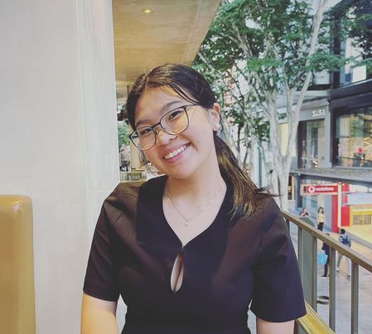
I'm passionate about education and skill development in shaping successful legal professionals. Over the past year, I've learned a lot from QUTLS events and workshops. Throughout the past year, I have had the privilege of being part of numerous QUTLS events and workshops, which have been invaluable experiences. These events have not only expanded my knowledge and skills but have also provided a platform for networking and personal growth.
I firmly believe that learning from these events has been a crucial aspect of my own development, and I would like to extend this opportunity to other law students. As Education Officer, I eagerly anticipate organising career workshops and fostering professional growth. I'm committed to attending events and offering support to the team whenever it's needed. Additionally, I'm fully dedicated to collaborating with the Director of Education and other officers to achieve our ongoing goal next year.
I'm currently a first-year student and truly understand adjustin g to university life can be overwhelming. I'm interested in the First Year Officer role because I want to help other first-year students adapt and feel comfortable at university. As a First Year Officer, I want to plan events and initiatives specifically for first-year students. I'm also excited to be there for first-year students as someone they can talk to. My goal is to offer support and guidance during this important part of their academic journey. I'm ready to attend events and be available to address their concerns. What's more, I have a genuine passion for connecting people, and I'm skilled at doing so. I'm eager to reach out and help create a supportive and inclusive community, which aligns perfectly with the First Year Officer role.

Gender and Sexuality Officer

No applications for Gender and Sexuality officer

Education Portfolio

Education Officer (2 Roles)

- Arash Asgari (3)
Education Officer Candidate Statement

Hello! My name is Arash Asgari and I was previously the External Competitions Officer for QUTLS.
In 2024, I will be a third-year student studying a Bachelor of Law/Business. Currently, I work as a paralegal for Clayton Utz.
My main motivation when joining the QUTLS was to receive support in navigating the confusing and scary world of law as a first-year student. Now in my third-year, I have a solid understanding of my future career pathway, and I want to help other students also ease their anxiety about their future.
If elected as an Education Officer, I endeavour to share the vast wealth of knowledge the QUTLS possesses with all students in an accessible and engaging format.
1. Personally, I have attended a majority of QUTLS education events and have a good working knowledge of each event’s unique offering. Additionally, I have conducted thorough research into post-graduate pathways, career prospects, and available professional opportunities; this knowledge positions me well to run an Education-focused portfolio.
2. Professionally, I am a well-organised and ambitious person with astute time management skills, being able to juggle full-time study, part-time work, and other personal obligations. This position me well for the Education portfolio as I can take on the high work volume without drowning in my other responsibilities. Additionally, I have a light subject load next year, have a VERY flexible casual position, and am happy to reduce work hours if needed.
3. QUTLS wise, I was the External Competitions Officer in 2023. In this capacity, I frequently communicated with external stakeholders and drafted several promotional messages for student, firm, faculty, and cross-university distribution. These experiences taught me how to tailor my communication style to accommodate different audiences, which will be highly beneficial for an Educator role. If elected, I promise my full commitment to the role.
Kind regards, Arash Asgari
- Carol Mitri (1)
Education Officer Candidate Statement

Hi, my name is Carol Mitri.
I am interested in taking on a more active role in QUTLS in 2024 as an education officer to work as part of a team to contribute to the education portfolio by organising events, workshops, and finding support tools for QUTLS members. Previously, I participated in the mentorship program for a few years as a mentor, however, this year I’m aiming to find more ways to contribute to the QUTLS education portfolio. I am passionate about creating more events that cater to the diverse interests of QUTLS members and finding more support tools for law students throughout their years of study at QUT. I aim to work on ensuring events at QUTLS are inclusive and access-friendly to all members.
I have extensive admin experience involving working on projects to ensure completion in a timely manner while juggling multiple aspects by working within a team to complete tasks for an optimal outcome. My experience includes organising events which involve logistics like bookings, catering, and event management. Furthermore, I intend to listen to feedback from QUTLS members and utilise my experience and the knowledge of fellow officers and directors to improve and ensure that events, workshops, and support provided are the best QUTLS can offer to its members.
Thanks for taking the time to review my application :)

- Ivy Smith (3)
Educatoin Officer Candidate Statement

My name is Ivy Smith, and I am currently completing a double degree in Fine Arts (Film)/Laws at QUT, with a Law, Technology and Innovation minor. I am currently in the second year of my degree and am particularly interested in Australian arts and communication regulation. I see myself one day working for a regulatory body such as ACMA or working in-house as a media lawyer for a production company.
I’m a lover and a taker of all opportunities, and this has led to some very interesting jobs and some very niche interests. Last year I ended up interning for an NFP in India redesigning their digital primary education model – I knew nothing about teaching! I worked recording textbooks for a while, I’ve been an adjudicator for the GC Debating Association for a few years, and I work for Brisbane International Film Festival every October. Needless to say, I’d had it in the back of my mind in August that I wanted to get involved in QUTLS when I saw a job posting on Facebook (you should follow it). Bingo!
It's definitely been a sprint toward the finish line since then. If elected for 2024, I'm eager to have time to brainstorm with my team ways in which we can take the portfolio in new directions next year. No matter what capacity I’ll be involved in in 2024, I’m keen to do it with this group of people.

- Olivia Chan (1)
Education Officer Candidate Statement

I'm passionate about education and skill development in shaping successful legal professionals. Over the past year, I've learned a lot from QUTLS events and workshops. Throughout the past year, I have had the privilege of being part of numerous QUTLS events and workshops, which have been invaluable experiences. These events have not only expanded my knowledge and skills but have also provided a platform for networking and personal growth.
I firmly believe that learning from these events has been a crucial aspect of my own development, and I would like to extend this opportunity to other law students. As Education Officer, I eagerly anticipate organising career workshops and fostering professional growth. I'm committed to attending events and offering support to the team whenever it's needed. Additionally, I'm fully dedicated to collaborating with the Director of Education and other officers to achieve our ongoing goal next year.
I'm currently a first-year student and truly understand adjustin g to university life can be overwhelming. I'm interested in the First Year Officer role because I want to help other first-year students adapt and feel comfortable at university. As a First Year Officer, I want to plan events and initiatives specifically for first-year students. I'm also excited to be there for first-year students as someone they can talk to. My goal is to offer support and guidance during this important part of their academic journey. I'm ready to attend events and be available to address their concerns. What's more, I have a genuine passion for connecting people, and I'm skilled at doing so. I'm eager to reach out and help create a supportive and inclusive community, which aligns perfectly with the First Year Officer role.

Mentor Officer

- Lance Andan (2)
Mentor Officer Candidate Statement

I am a highly motivated and committed individual with strong communication and organisational skills. I have always been brought up with the strive to be excellent where I carry out my work with a positive attitude, finding solutions to p roblems that I am presented with and take initiative when appropriate. This leads me to believe I can meet the expectations of the roles I have selected.
For an events officer role, I have always been someone with a keen eye for details that would contribute to the bigger picture. I always love going to events, such as balls, and I want to explore the aspect of what it means to be a reliable person who can plan not just for myself, but for everyone else. I also want the next few years to do with QUTLS-related events as an event people know will be a good one, rather than the disappointments being put as of recent. I am confident I am able to work well with people as it is one of my better skills and can provide a great deal of help and judgment on specific details.
For the mentor officer role, I was privilege enough to have experienced a mentor during my first year and would love to be one of the people that first years can go to for anything. I am always happy to provide the skills and lessons I've learnt thus far in law school, and can hopefully pass that wisdom down through very important events throughout the year. I am confident I provide a great deal of skill to make others feel quite comfortable (probably from the amount of time I talk) to ensure the new batch of first years will feel welcomed and feel as if law school may not be as scary as they first thought. Being a mentor would mean I also get to work a great deal with the first year officer. As such, I feel as if I can bring these sets of skills in this role as a first year officer too. Although I prefer being the right-hand man to others, I am not afraid to step up if needed and can provide a great deal of hospitality, kindness, and warmth that's needed for these two roles in particular.

Events Portfolio

Events Officer (2 Roles)

- Ethan Lee Hang (2)
Events Officer Candidate Statement

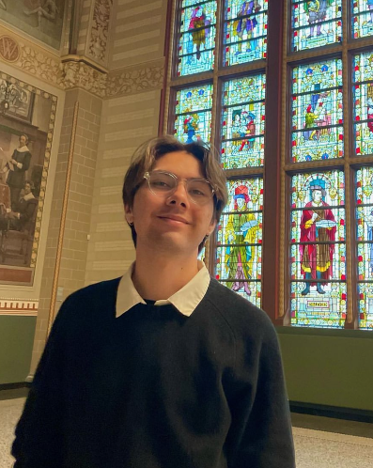
So you don’t trust me for the director role? That’s okay, but did you read my last statement! I am keen on ensuring that you have the best time. A vote for me in the team, is guarantee* that you will enjoy some of the most iconic events in 2024.

- Harrison Megom (3)
Event Officer Candidate Statement

I would like to be in the events because I am passionate about the events that the QUTLS hosts. From Pub Crawl through to Law Dinner, I have enjoyed attending each and every one of them over the years, however I think that more can be done with events and there can be more room for law students to meet and enjoy themselves and get to know one another.
This past year I have enjoyed the responsibility of being the Director of Creativity, and with my team organized multiple events to much success. I believe I have the passion and skill to really guide this portfolio.

- Lance Andan (1)
Event Officer Candidate Statement
I am a highly motivated and committed individual with strong communication and organisational skills. I have always been brought up with the strive to be excellent where I carry out my work with a positive attitude, finding solutions to p roblems that I am presented with and take initiative when appropriate. This leads me to believe I can meet the expectations of the roles I have selected.
For an events officer role, I have always been someone with a keen eye for details that would contribute to the bigger picture. I always love going to events, such as balls, and I want to explore the aspect of what it means to be a reliable person who can plan not just for myself, but for everyone else. I also want the next few years to do with QUTLS-related events as an event people know will be a good one, rather than the disappointments being put as of recent. I am confident I am able to work well with people as it is one of my better skills and can provide a great deal of help and judgment on specific details

- Oriel Hull (3)
Event Officer Candidate Statement

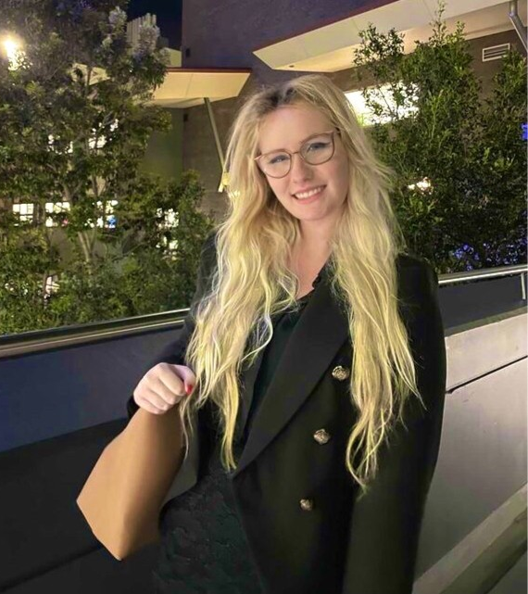
I am excited to be expressing my interest in an executive officer position with the QUTLS. I have been an active participant in the QUTLS throughout my degree, and in 2023 was an internal competitions officer. I’ve thoroughly enjoyed this position and hope to continue in it or a similar executive position next year.
As I have previously filled the internal competitions officer position, I am familiar with QUTLS’ internal competitions and what is required to run them. I have experience engaging with sponsors through my other university society position and have directly liaised with many of QUTLS’ sponsors in organising internal competitions. I also have event co-ordination experience from these roles.
Throughout my time at QUT, the QUTLS has provided me with many, extremely valuable resources and experiences, not only in regard to my academic progression, but my networks and future in the legal industry. I very much look forward to contributing to and supporting these opportunities for other QUT students.

Merchandising Officer

- Calissa Leyden (3)
Merchandising Officer Candidate Statement

My name is Calissa, and I am a third-year law and communications student, I am applying for the finance officer, sponsorship officer, as well as the merchandising officer positions. I want to join the QUTLS committee to be able to meet more like-minded people and to become more involved with the society. I am nominating myself for the finance officer position. I believe that I am most suited for this position, as I have had some experience with managing the financials of a few of my previous workplaces. Although I don't have that much experience, I have a lot of enthusiasm, as I am very passionate about financial literacy, in particular taxation. Furthermore, I believe that my organisation skills will allow me to assist the treasurer in the management of the society’s financials and any other tasks. In the event that I am not nominated as finance officer, I have nominated to be the sponsorship officer. I feel as though sponsorship is often something that is overlooked however is key to the running of the club, as well as maintaining the reputation of QUT law students. I believe that I am suited to this role, as I am passionate about making and maintaining connections within the commercial setting. In the event that I am not nominated as the sponsorship officer, I have nominated to be the merchandising officer. I believe that I am well suited to this position, as I have a sound understanding of the importance of branding and have experience with maintaining and ordering stock.

External Competitions Portfolio

External Competitions Officer
No applications for external competitions officer

First Nations Officer
No applications for First Nations Officer

Finance Officer

- Calissa Leyden (1)
Finance Officer Candidate Statement

My name is Calissa, and I am a third-year law and communications student, I am applying for the finance officer, sponsorship officer, as well as the merchandising officer positions. I want to join the QUTLS committee to be able to meet more like-minded people and to become more involved with the society.
I am nominating myself for the finance officer position. I believe that I am most suited for this position, as I have had some experience with managing the financials of a few of my previous workplaces. Although I don't have that much experience, I have a lot of enthusiasm, as I am very passionate about financial literacy, in particular taxation. Furthermore, I believe that my organisation skills will allow me to assist the treasurer in the management of the society’s financials and any other tasks.
In the event that I am not nominated as finance officer, I have nominated to be the sponsorship officer. I feel as though sponsorship is often something that is overlooked however is key to the running of the club, as well as maintaining the reputation of QUT law students. I believe that I am suited to this role, as I am passionate about making and maintaining connections within the commercial setting.
In the event that I am not nominated as the sponsorship officer, I have nominated to be the merchandising officer. I believe that I am well suited to this position, as I have a sound understanding of the importance of branding and have experience with maintaining and ordering stock.

- Gabrielle M Bielawski (2)
Finance Officer Candidate Statement

My name is Gabrielle. I’m a Graduate Entry law student, going into my penultimate year in 2024. My undergraduate degree was an extended major in Linguistics with a double minor in Mandarin and Aboriginal & Torres Strait Islander Studies.
I currently work as the Queensland Spirit Specialist for a global spirits company, managing national sales deals, key accounts, group accounts, and international hotel accounts in Far North Queensland. I work across numerous diaries and host events in key cities such as Sydney and Melbourne. Within one year working in my position, I have successfully increased Queensland’s Moving Annual Total purchasing from $3.2 million to almost $4 million in a post-pandemic arena, leveraging and creating assets, renegotiating deals, and amending budgets, as well as increasing value per dollar spent while national data illustrated a decrease in volume.
My commitment to not only the legal sector but with the law student experience runs deep.
As someone pursuing her postgraduate studies in Law, I’ve had a number of years experience understanding and the living out the needs that students require on a foundational level, as well as on a level that ensures quality, enrichment of experience, and memories for years to come. I believe I can achieve this while thoroughly maintaining a healthy and thriving budget for the Law Society.
I would be thrilled to be elected as the QUTLS Treasurer where I can offer my skills and knowledge in finance, as well as leveraging my contacts in the industry to provide a memorable and rich experience for QUT Law Students.
Thanks for your consideration, everyone!

Internal Competitions

Internal Competitions Officer (4 Roles)

- Emily-Rose Turton (2)
Internal Competitions Officer Candidate Statement

Hi, my name is Emily! I’m a third-year law and justice student, and I’m applying for the Competitions Officer position. I’ve made many friends through QUTLS events and I’m keen to contribute to helping shape these same experiences for commencing law students.
My experience participating in a QUTLS competition was very positive and I wish to provide the same experience to other students. I participated in the Client Interview Competition in 2022 and felt supported throughout the competition and found all communication was incredibly clear, succinct and professional.
I believe I am well-suited to the role of Competitions Officer as I am also highly organised and effective in my communication. In my current role as a Senior Paralegal, I communicate frequently with a diverse range of people to achieve various outcomes in a professional environment, both verbally and in writing. I am highly organised, and I am effective at planning as I maintain management of numerous files with competing priorities and deadlines. These experiences provide me with the necessary skills for the role to ensure competitors receive clear, timely communication in competitions and feel supported during the process.
QUTLS competitions are a valuable form of experience for law students, and I would love to work on increasing reach and participation so more students can gain the practical benefits offered. I would love to bring my experience, knowledge, and skills to the QUTLS Competitions Officer role, and I really appreciate your consideration of me for this role!

- Oriel Hull (2)
Internal Competitions Officer Candidate Statement

I am excited to be expressing my interest in an executive officer position with the QUTLS. I have been an active participant in the QUTLS throughout my degree, and in 2023 was an internal competitions officer. I’ve thoroughly enjoyed this position and hope to continue in it or a similar executive position next year.
As I have previously filled the internal competitions officer position, I am familiar with QUTLS’ internal competitions and what is required to run them. I have experience engaging with sponsors through my other university society position and have directly liaised with many of QUTLS’ sponsors in organising internal competitions. I also have event co-ordination experience from these roles.
Throughout my time at QUT, the QUTLS has provided me with many, extremely valuable resources and experiences, not only in regard to my academic progression, but my networks and future in the legal industry. I very much look forward to contributing to and supporting these opportunities for other QUT students.

- Claudia McMahon (1)
Internal Competitions Officer Candidate Statement

Hello! I'm Claudia and I'm so excited to nominate for the Competitions Officer position. Throughout my study as a Laws/Fine Arts student I have excelled as a collaborator and communicator in both academic and extracurricular settings. For example, I was a Grand Finalist in this year’s Junior Moot. I felt thoroughly supported by the Competitions portfolio throughout my first competitive mooting experience and would love the opportunity to extend this support to future competitors. My attention to detail, time management and organisation skills make me a strong candidate for this position. I look forward to getting involved in facilitating the fantastic competition opportunities available to QUT Law students.

IT Officer

No applications for IT Officer

Media and Communications Portfolio

Publications Officer (2 Roles)

- Seren Conway (2)
Publications Officer Candidate Statement
My name is Seren Conway and I am a third year law student currently work full time at LawSolve/NFP Lawyers as a Paralegal and Precedent Development Officer and study part time. In my role at LawSolve and NFP Lawyers, I have researched, written and proofread many legal documents such as legal advices and affidavits.
I also am heavily involved in coordinating, researching, writing and proofreading legal articles and Canva fact sheets for the firms’ websites, particularly for NFP Lawyers as the law in the charity, fundraising and tax space is ever developing. In my free time, I am a frequent gym goer, avid book worm and podcast listener. My favourite books and podcasts consist of biographical, historical, political, finance, journalism and legal pieces. I would love to get involved!

Social Media Officer

- Seren Conway (1)
Social Media Officer Candidate Statement

My name is Seren Conway and I am a third year law student currently work full time at LawSolve/NFP Lawyers as a Paralegal and Precedent Development Officer and study part time. In my role at LawSolve and NFP Lawyers, I have researched, written and proofread many legal documents such as legal advices and affidavits.
I also am heavily involved in coordinating, researching, writing and proofreading legal articles and Canva fact sheets for the firms’ websites, particularly for NFP Lawyers as the law in the charity, fundraising and tax space is ever developing. In my free time, I am a frequent gym goer, avid book worm and podcast listener. My favourite books and podcasts consist of biographical, historical, political, finance, journalism and legal pieces. I would love to get involved!

- Ethan Lee Hang (3)
Social Media Officer Candidate Statement

I have an eye for aesthetics, for ensuring that every little detail is perfect. I am a social media micro-influencer (trust me I had a Tiktok with 10k likes once). I would love to be the social media officer, as I know how to get engagement, how to make things look pretty, and how to post in a captivating way. I am organised, and run like the Shinkansen. A vote for me will ensure that all QUTLS pages are run efficiently, organised and look pretty!

Moot Club Portfolio

Moot Club Officer

- Emily-Rose Turton (2)
Moot Club Officer Candidate Statement

Hi, my name is Emily! I’m a third-year law and justice student, and I’m applying for the Competitions Officer position. I’ve made many friends through QUTLS events and I’m keen to contribute to helping shape these same experiences for commencing law students.
My experience participating in a QUTLS competition was very positive and I wish to provide the same experience to other students. I participated in the Client Interview Competition in 2022 and felt supported throughout the competition and found all communication was incredibly clear, succinct and professional.
I believe I am well-suited to the role of Competitions Officer as I am also highly organized and effective in my communication. In my current role as a Senior Paralegal, I communicate frequently with a diverse range of people to achieve various outcomes in a professional environment, both verbally and in writing. I am highly organised, and I am effective at planning as I maintain management of numerous files with competing priorities and deadlines. These experiences provide me with the necessary skills for the role to ensure competitors receive clear, timely communication in competitions and feel supported during the process.
QUTLS competitions are a valuable form of experience for law students, and I would love to work on increasing reach and participation so more students can gain the practical benefits offered. I would love to bring my experience, knowledge, and skills to the QUTLS Competitions Officer role, and I really appreciate your consideration of me for this role!

Sponsorship Portfolio

Sponsorship Officer

- Arash Asgari (2)
Sponsorship Officer Candidate Statement

Hello! My name is Arash Asgari and I was previously the External Competitions Officer for QUTLS. In 2024, I will be a third-year student studying a Bachelor of Law/Business. Currently, I work as a paralegal for Clayton Utz. My main motivation when joining the QUTLS was to receive support in navigating the confusing and scary world of law as a first-year student. Now in my third-year, I have a solid understanding of my future career pathway, and I want to help other students also ease their anxiety about their future. If elected as Sponsorship Officer, I endeavour to nurture and develop QUTLS’s relationships with external stakeholders to help fund and run the various portfolios. 1. Personally, I have attended a majority of QUTLS events and have a good working knowledge of each event’s unique offering. Additionally, I have reviewed the Sponsorship Prospectus; this knowledge positions me well to advertise and sell QUTLS’s offering to interested firms and parties. Moreover, I have developed a professional relationship with most firms over the last 2 years, which will be beneficial when further developing the QUTLS’s existing relationships and reputation as a value-add organisation. 2. Professionally, I am a well-organised and ambitious person with astute time management skills, being able to juggle full-time study, part-time work, and other personal obligations. This position me well for the Sponsorship portfolio as I can take on the high work volume without drowning in my other responsibilities. Additionally, I have a light subject load next year, have a VERY flexible casual position, and am happy to reduce work hours if needed. 3. QUTLS wise, I was the External Competitions Officer in 2023. In this capacity, I frequently communicated with external stakeholders and drafted several promotional messages for student, firm, faculty, and cross-university distribution. These experiences taught me how to communicate in a professional capacity, which is highly beneficial for a Sponsorship role. If elected, I promise my full commitment to the role.
Kind regards, Arash Asgari

- Calissa Leyden (2)
Sponsorship Officer Candidate Statement

My name is Calissa, and I am a third-year law and communications student, I am applying for the finance officer, sponsorship officer, as well as the merchandising officer positions. I want to join the QUTLS committee to be able to meet more like-minded people and to become more involved with the society. I am nominating myself for the finance officer position. I believe that I am most suited for this position, as I have had some experience with managing the financials of a few of my previous workplaces. Although I don't have that much experience, I have a lot of enthusiasm, as I am very passionate about financial literacy, in particular taxation. Furthermore, I believe that my organisation skills will allow me to assist the treasurer in the management of the society’s financials and any other tasks. In the event that I am not nominated as finance officer, I have nominated to be the sponsorship officer. I feel as though sponsorship is often something that is overlooked however is key to the running of the club, as well as maintaining the reputation of QUT law students. I believe that I am suited to this role, as I am passionate about making and maintaining connections within the commercial setting. In the event that I am not nominated as the sponsorship officer, I have nominated to be the merchandising officer. I believe that I am well suited to this position, as I have a sound understanding of the importance of branding and have experience with maintaining and ordering stock.

- Oriel Hull (1)
Sponsorship Officer Candidate Statement

I am excited to be expressing my interest in an executive officer position with the QUTLS. I have been an active participant in the QUTLS throughout my degree, and in 2023 was an internal competitions officer. I’ve thoroughly enjoyed this position and hope to continue in it or a similar executive position next year.
As I have previously filled the internal competitions officer position, I am familiar with QUTLS’ internal competitions and what is required to run them. I have experience engaging with sponsors through my other university society position and have directly liaised with many of QUTLS’ sponsors in organising internal competitions. I also have event co-ordination experience from these roles.
Throughout my time at QUT, the QUTLS has provided me with many, extremely valuable resources and experiences, not only in regard to my academic progression, but my networks and future in the legal industry. I very much look forward to contributing to and supporting these opportunities for other QUT students.

Sport and Health Portfolio

Health Officer

- Carol Mitri (3)
Health Officer Candidate Statement

Hi, my name is Carol Mitri.
I am interested in taking on a more active role in QUTLS in 2024 as an education officer to work as part of a team to contribute to the education portfolio by organising events, workshops, and finding support tools for QUTLS members. Previously, I participated in the mentorship program for a few years as a mentor, however, this year I’m aiming to find more ways to contribute to the QUTLS education portfolio. I am passionate about creating more events that cater to the diverse interests of QUTLS members and finding more support tools for law students throughout their years of study at QUT. I aim to work on ensuring events at QUTLS are inclusive and access-friendly to all members.
I have extensive admin experience involving working on projects to ensure completion in a timely manner while juggling multiple aspects by working within a team to complete tasks for an optimal outcome. My experience includes organising events which involve logistics like bookings, catering, and event management. Furthermore, I intend to listen to feedback from QUTLS members and utilise my experience and the knowledge of fellow officers and directors to improve and ensure that events, workshops, and support provided are the best QUTLS can offer to its members.
Thanks for taking the time to review my application :)

- Charles Cooper (2)
Health Officer Candidate Statement

HI there! My name is Charlie and I'm a first year graduate entry law student who loves sport and is keen on getting involved with the QUTLS. My goal as Sports Officer is to inspire my fellow law students to get involved in sport so they can experience the social, mental and physical benefits it has to offer.
In September, I competed at the 2023 Uni Games in the QUT Men's Football Team. This experience allowed me to form connections with other QUT students, including other law students. Additionally, I've played social sports throughout my time at QUT, but have always wanted to have a role in coordinating and promoting sport for other students at university.
Outside of my studies, I've been volunteering for the Refugee and Immigration Legal Service (RAILS) and at the 2023 Women's World Cup. Both these experiences have highlighted to me the power of volunteering and how sport can bring people together from all walks of life.
In August, I was chosen to fill in this role for the remaining part of the year. I haven't yet had the opportunity to get as involved as I'd like and would love to continue in this role and plan sporting events for QUTLS. Since becoming a QUTLS member, I've enjoyed attending the Touch Footy Grudge Match and the Mental Health Breakfast. I hope I can attend more events like these representing the society as its Sport Officer.
In summary, I would love the opportunity to be the Sports Officer for the QUTLS as I'm passionate about promoting healthy habits, socialising and enjoyment of sport for my fellow QUTLS members.

Sport Officer

- Brooklyn Hall (1)
Sport Officer Candidate Statement

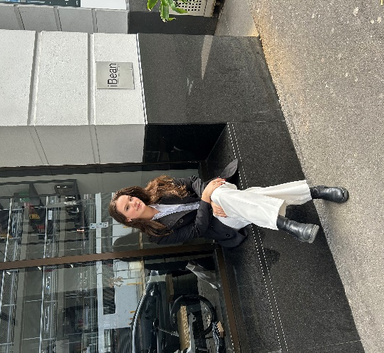
Hey! I would love this opportunity to tell you why I am a great fit for the sports officer position. This coming year I really want to be more involved with uni events, and I feel like a great way to do that is through the law society.
I’m a huge advocate for the positive effects sports can have on not just physical but mental health as well. It’s also a great opportunity to meet new people and hang out! I hope that my want to get involved and have a good time can encourage others to do the same. This enthusiasm is what I hope to provide in the position of sports officer.

- Charles Cooper (1)
Sport Officer Candidate Statement

HI there! My name is Charlie and I'm a first year graduate entry law student who loves sport and is keen on getting involved with the QUTLS. My goal as Sports Officer is to inspire my fellow law students to get involved in sport so they can experience the social, mental and physical benefits it has to offer.
In September, I competed at the 2023 Uni Games in the QUT Men's Football Team. This experience allowed me to form connections with other QUT students, including other law students. Additionally, I've played social sports throughout my time at QUT, but have always wanted to have a role in coordinating and promoting sport for other students at university.
Outside of my studies, I've been volunteering for the Refugee and Immigration Legal Service (RAILS) and at the 2023 Women's World Cup. Both these experiences have highlighted to me the power of volunteering and how sport can bring people together from all walks of life.
In August, I was chosen to fill in this role for the remaining part of the year. I haven't yet had the opportunity to get as involved as I'd like and would love to continue in this role and plan sporting events for QUTLS. Since becoming a QUTLS member, I've enjoyed attending the Touch Footy Grudge Match and the Mental Health Breakfast. I hope I can attend more events like these representing the society as its Sport Officer.
In summary, I would love the opportunity to be the Sports Officer for the QUTLS as I'm passionate about promoting healthy habits, socialising and enjoyment of sport for my fellow QUTLS members.

